APPLICATION SOFTWARE

Databases
A database is a structured set of information, which describes a part of the real world (like a library’s register or stock records).
Database systems
The tools for making, updating and analysing a database are called database programmes. The most popular database systems are MS Access, Paradox or FoxPro. For larger databases there are used Informix and Oracle systems.

Relational data model (RM)
Relational model used in database systems has a simple structure. Data are arranged in tables which are interconnected by logical relations. We can work with the data, look them up, copy, classify or compare them.

Database programmes are formed by database objects – TABLE, QUERY, FORM and REPORT

A TABLE is a set of information about a subject. For example, table “Employees” includes data about a company’s employees. The data are arranged in lines (record) and columns (field).

Table EMPLOYEES
No of empl. | name | address | Date of birth | salary
122 | Ivan Volný | Ostrava | 1. 1. 1950 | 10 000
123 | Jan Novák | Havířov | 1. 2. 1970 | 12 000
name of the field
record

field
A record is every line in a database table. It contains information about one object. All records have the same structure. E.g. in the Table EMPLOYEES every line is focused only on one employee. As a described object we can also consider a book in the library database or a patient in a medical record.
A field is a column in a table. It includes a certain part of the information about a described object. E.g. a field in the Table EMPLOYEES is the address of the person. Every record in the table contains the same fields. We can add another filed and change its properties.
Data type and the length are important when we make a field. Every field includes only data of the same data type, for example, text, date, number (No).

A primary key is a field or a group of fields that obviously determines a record. It guarantees that every record will be written in the table only once, e.g. a birth certificate number of the employee, a registration number of the car. The birth date is not a right primary key because more people might be born on the same date. That means that it is not possible to determine the record in the table clearly.
Database relation
If you want to make up more tables for single objects in the database, it is necessary to choose a correct application that assembles all the information. A relation is a way of linking single tables so that they could communicate and share the common data.

There are three types of relational databases:
- Relation 1:1
We use this relation if one record in the first table corresponds only with one record in the second table.

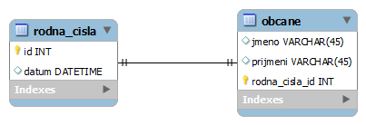

- Relation 1.N
This relation is used between two tables when one record in the first table corresponds with several records in the second table. Every information in the database is displayed only once. This relation is
used most often.
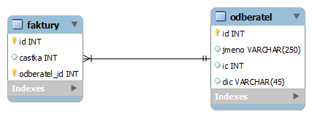

- Relation M:N
This relation is used if more records in one table correspond with more records in the second table.

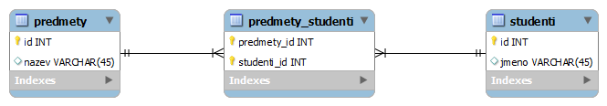

A QUERY serves to display, modify and analyse the data in a table. A query is able to choose data from tables according to given criteria and to use the data for computing. They can also be used as the source of records for forms and reports.
A FORM is a user’s interface for accessing the data saved in tables. It is a database object used for entering, modifying and displaying the data in a database. It can also be used as a switchboard, which enables opening other forms and reports. Forms are bound to one or more tables or queries. All changes made in the form are shown in the table. We can add other information into the form (e.g. images, explanatory notes).
REPORT is a database object that enables to display, present or print data. It sets the right data, their amount, layout or arrangement. We can use a filter to sort out the record.
Database normalization
Database normalization is a process used to organize a database into tables and columns.
The goals of the normalization process are to reduce the amount of space a database consumes and ensure that data is logically stored. The rules for normalization of the database are called normal forms. If the table satisfies the first rule, we talk about 1st normal form (the lowest form of normalization). If the table satisfies first three rules, then we talk about 3rd normal form. There are other normal forms (BOYCE-CODD normal form – BCNF, 4th normal form) but the 3rd form is used most often for most applications.
- First Normal Form – The information is stored in a relational table and each column contains atomic values, and there are not repeating groups of columns.
- Second Normal Form – The table is in second normal form and all the columns depend on the table’s primary key¹.
- Third Normal Form – the table is in the third normal form and all of its columns are not transitively dependent on the primary key

To identify records in tables a primary key is used. Data are saved in a large number of different tables, which can be interconnected. It is a combination of columns which uniquely specify a row.

Vocabulary
database programmes | databázové programy
relational database models | relační databázové modely
interconnected | propojený
database objects | databázové objekty
lines and columns | řádky a sloupce
table | tabulka
form | formulář
query | dotaz
report | sestava, záznam
primary key | primární klíč
property | vlastnost
determine | určit, stanovit. vymezit
guarantee | zaručovat
birth certificate number | rodné číslo
switchboard | přepínací panel
registration number of the car | SPZ
relation | relace
assemble | shromáždit, zkompletovat
modify | modifikovat (upravit, pozměnit)
compute | vypočítat
user interface | uživatelské rozhraní
switchboard | přepínací panel
setting up | sestava
database normalization | normalizace databáze
normal form | normální forma
satisfy | splňovat
atomic value | atomická hodnota (nedělitelná)
transitively | tranzitivně

Practice
- Translate:
tabulka
dotaz
formulář
přepínací panel
uživatelské rozhraní
upravit data
Shromažďovat informace

- Odd one out:
- table – query – primary key – form – report
- MS Access – Paradox – FoxPro – Mac OS X – Oracle
- database – set of information – description of real world – database programmes

- Complete:
- Database programmes …………………, ………………………… and analyse a database.
- A …………………… serves to display, modify and analyse the data in a table.
- The database object used for entering, modifying and displaying the data is called a …………………………….
- The object that summarizes and presents the data in a database is called a …………………………………………………….
- A form can also be used as a …………………………………….., which enables opening other forms and reports.

- Match the words with the right definitions:
- A primary key is a column in a table. It includes a certain part of the information about
a described object.
- Database normalization is a process used to organize a database into tables and columns.
- A field is a user’s interface for accessing the data saved in tables.
- A relation is a way of linking single tables so that they could communicate and
share the common data.
- A table is a set of information about a subject.

